def mask_pii(input_string, mask_char="X"):
"""
Masks all sections of a hyphen-separated string except the last one.
"""
print(f"\n--- Processing: {input_string} ---")
# Step 1: Breakdown
# Create a variable and use the split() method on the hyphen (-)
parts = input_string.split("-")
print(f"Step 1 (Breakdown): {parts}")
# Step 2: Loop
# Iterate through the list. We use len(parts) - 1 to ignore the last index (-1)
for i in range(len(parts) - 1):
# Replaces the digits with the mask_char while maintaining the original length
parts[i] = mask_char * len(parts[i])
print(f"Step 2 (Masked List): {parts}")
# Step 3: Re-assembly
# Use the "-".join() method to combine the list back into a single string
masked_string = "-".join(parts)
print(f"Step 3 (Re-assembly): {masked_string}")
return masked_string
# --- Validation Tests ---
# Credit Card Test
cc_input = "4532-8812-9001-4321"
cc_result = mask_pii(cc_input)
print(f"Final Output: {cc_result}")
# Phone Number Test
phone_input = "123-456-7890"
phone_result = mask_pii(phone_input)
print(f"Final Output: {phone_result}")
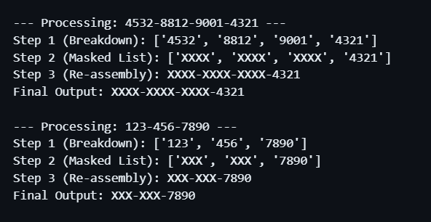

To perform the data masking, the script first uses the split() method on the hyphen (-) to break the input string down into a list of separate strings. Next, a loop iterates through this list using a -1 index, which ensures the final section is skipped and the last four digits remain visible while the rest are masked. To re-assemble the data, the "-".join() method is used to combine the list back into a single string. This approach successfully preserves the original hyphens, satisfying the assignment's constraints. Finally, the script was validated using the phone number "123-456-7890", successfully and automatically outputting the correctly masked version.

